name: Amina Kenewa
Student number: 6512017

PROTOYPE 1
Define the research question for this prototype in one or two sentences.  (What were you trying to find out?) | How can I create a VR Headset using cheap, affordable materials?  - Am I able to create a VR headset at home?  - Does it work?  - How long does it take to assemble?  - Does it have the same or similar effect as a bought standard headset?
Give a bit more background information as to why you did this prototyping?  (How does it fit in to the bigger picture of your proposed project?) | Based on primary research, I found that it was very difficult to find and gain access to VR headsets / cardboard in the region of Algeria I am visiting as its still not common and widely used. Also because of the difference in street structure in the city of El -Oued there are no home addresses or mailing address. Thus making it very difficult and impossible to order online. Even if it was to be ordered to the capital it will take weeks to be transported to El-Oued and has to be done through personal connections. (this source of information was retrieved by immediate family members and friends currently living in El- Oued. This is a problem as it limits my audience in Algeria and specifically El-Oued. My project will only be viewed when I go and take a headset with me however, when I come back there will be no tools for them to continue viewing mine or any other VR content.  This is why I came up with this research question as its offering a solution to the problem I will be facing in the long run not only for Algeria but also for any other small slow developing countries who will have the same difficulties obtaining the headsets like in El- Oued.
Describe the method you used.  (what, where, when, who, how?) | Firstly, I researched what the components of a Virtual Reality Cardboard headset is made out of. Then I researched where I can find cheap alternatives to these materials and if I am able to find these exact materials abroad or ones that can work just as well.  From the research I found that for this prototype I will need:  - Scissors  - Card Board  - Pen/pencil (for markings and measuring)  - Hot glue gun/ any form of strong glue  - Ruler  - Circle measurer/ stencil  - Thrift lens from an X5 magnifying glass (two needed)  - Ribbon/ thread  - Elastic band  - Choice of decoration.  I have contacted my connections in El-Oued and asked if these items were found or easy to source and they were.  Steps  - Measure and cut out Cut out all pieces. Leaving a space of 1.5 cm for gluing.  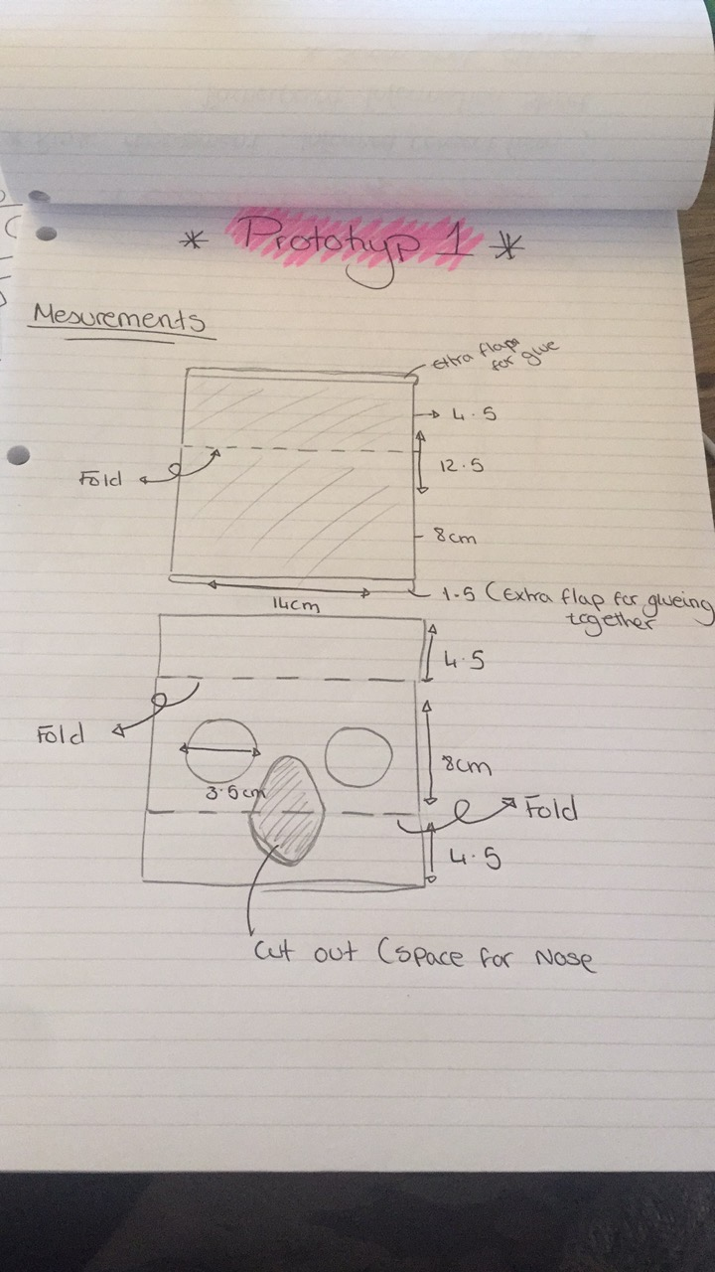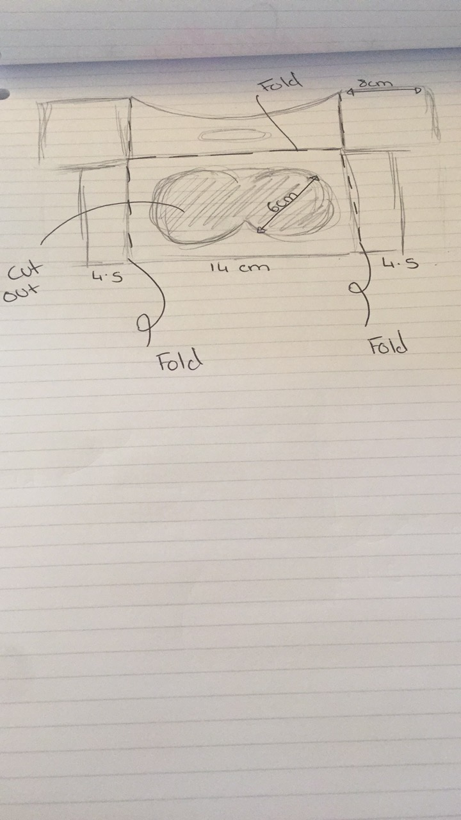  - If the card board is weak cut 2 stencils out and layer for extra strength. I ended up changing the card board to a flatter one a the first one I used to have a rigged texture which made it hard to fold accurately and cut neatly.  - Use the hot glue gun/ glue all pieces together. I began using a glue stick but ended up going back a securing all piece together with the glue gun for extra support.  - Glue the magnifying lenses in to the smaller circles. Once the paint dried I glued the lens in but some residue got on the glass causing it to blur.  I followed this tutorial I found when I got stuck half way through. The measurements are different but I used their assembling technique. (https://www.youtube.com/watch?v=8qNmRi-gNqE)  Reference to aid:  How To Make Vr Cardboard Easy | Vr Headset At Home (2018) [DVD] Youtube: Creativity Buzz.
Supply some documentation of your prototype being conducted  (for example: photographs, written responses, screenshots, url for a short video etc) | https://livecoventryac-my.sharepoint.com/personal/kenewaa3_uni_coventry_ac_uk/_layouts/15/guestaccess.aspx?guestaccesstoken=PDni6fzyXWVDAcu4ClMi7L9zg9X8wE552F4Fo1xyz1w%3D&docid=2_12eb51baf30454fbf8d66efa1e9a74c77&rev=1&e=hep6jI
What did you learn from this prototype?  (What were the results? What might you do differently next time as a result?) | This prototype surprisingly worked better than expected, and I was able to view the content as a joint VR screen. however, there were issues when it came to aligning the video to the headset. On usual VR cardboards there is a QR code place on the side which configures and pairs the devise to the browser and plays the video in proportion to the screen size and headset. Thus allowing a truly mesmerizing experience. Another issue is that the parts were not tightly sealed so light was entering and that effected the experience as it was distracting. Although all these items were found in Algeria (El-Oued) the X5 magnifying glass is very expensive and costs what is equivalent to 15 British pounds per lens. The factors I would change would be tightening/ lessening on the measurements so that it would be tightly sealed. Also figuring out a cheaper alternative to the lens so that is more affordable without compromising the quality of the viewing for everyone.
How will you incorporate this learning into your project proposal? | I have incorporated this finding to my project proposal as I had decided to include a webpage where I provide the finalized and perfected measurements and tools to create your own DIY VR headset for your own personal use. Making it cheap and affordable whilst also being easy to follow. This headset wont give the same experience as a google headset however, it will give and experience as close to having the real headset.

PROTOYPE 2
Define the research question for this prototype in one or two sentences.  (What were you trying to find out?) | How to make a VR headset using items found at home?  - Not using any bought items for this project.  - Is it possible to create?  - Does it work ?
Give a bit more background information as to why you did this prototyping?  (How does it fit in to the bigger picture of your proposed project?) | This was done for the same reasons as prototype 1, however I wanted to take it further and make it completely FREE. Therefore, without using the lens and researching alternatives. This is because spending 15 pounds on one lens is considered very expensive and is not worth it if the experience is not as top notch as the original.
Describe the method you used.  (what, where, when, who, how?) | I followed the same steps as prototype one however I replaced the lens with a method I found on YouTube where they used plastic bottles and water to create a convex bottle lens.  This method takes longer as we have to be super careful when poring the water between the two lens circles.  From the research I found that for this prototype I will need:  - Scissors  - Card Board  - Pen/pencil (for markings and measuring)  - Hot glue gun/ any form of strong glue  - Ruler  - Circle measurer/ stencil  - Thrift plastic clear bottle  - Ribbon/ thread  - Elastic band  - Choice of decoration.  Steps  - Follow all the above steps for measurements  - Use a clear bottle a measure 33mm in diameter cut out 4 equal sides.  - Cutting plastic can be really difficult so I used the heat from the hot glue gun to melt the edges of and that gave me a cleaner cut.  - Let it set before cluing down the edges leaving a little opening at the top.  - Pour water in to it and glue it shut (this was the trickiest part as you need to work fast.  I used this video as a reference and guide :  https://www.youtube.com/watch?v=Za_h1resks0  Reference to aid:  (2018) [DVD] How to make VIRTUAL REALITY lens using plastic bottle-convex/magnifying lens: BOKIN DIY
Supply some documentation of your prototype being conducted  (for example: photographs, written responses, screenshots, url for a short video etc) | https://livecoventryac-my.sharepoint.com/personal/kenewaa3_uni_coventry_ac_uk/_layouts/15/guestaccess.aspx?guestaccesstoken=Vs5BAK9iS%2BPEBmDlTX2MoCkZZFKG3VM6sbOenQXPwrQ%3D&docid=2_151b994ff1dcc4c648fc22cb04d8bb358&rev=1&e=0OBj9r
What did you learn from this prototype?  (What were the results? What might you do differently next time as a result?) | This prototype had so much potential if it actually worked the problems I faced was that I got air bubbles and greasy residue on the lens. This affected the viewing experience and made it difficult to actually see the content. What I would do next time is not use an oil bottle even though I had cleaned it, there was some stubborn grease left on the bottle therefore making the lens blurry. This also affected the water as it started to form bubbles inside like a lava lamp. I would also opt for a sharper cutting instrument to make the edges crispier and maybe use super glue in small dosages as hot glue gun dried chunky.
How will you incorporate this learning into your project proposal? | This can actually work as a completely free version of a VR headset.  However, I will recreate it making the changes and decide on weather or not I will feature it as a alternative method if its worth the try and actually works. Thus, providing the audience with two choice and allowing them to choose a method they want.

PROTOYPE 3
Define the research question for this prototype in one or two sentences.  (What were you trying to find out?) | How to clearly articulate step by step information to the Arabic speaking audience?  - Will it be formal?  - Tone  - pronunciation
Give a bit more background information as to why you did this prototyping?  (How does it fit in to the bigger picture of your proposed project?) | As the audience that will be struggling to get the VR headsets primarily from Algeria, the main language there is Arabic. Therefore, I will need to create a script in Arabic and record the audio and get it checked and tested for any grammatical or pronunciation errors before publishing. I will be filming the video separately showing only my hands doing the necessary tasks then pairing the audio separately. This way I can reuse the video and get the audio translated in other required languages.
Describe the method you used.  (what, where, when, who, how?) | The method for this was that I created a brief script in English my strongest language, bullet pointing the content I needed to address.  I then followed it up with research and partnering with a coworker in my part time job as an Arabic school teacher, I was able to formally translate the script. I recorded many versions and got feedback from co workers and and Arabic speaking family and friends on my delivery and fluency of speech.
Supply some documentation of your prototype being conducted  (for example: photographs, written responses, screenshots, url for a short video etc) | 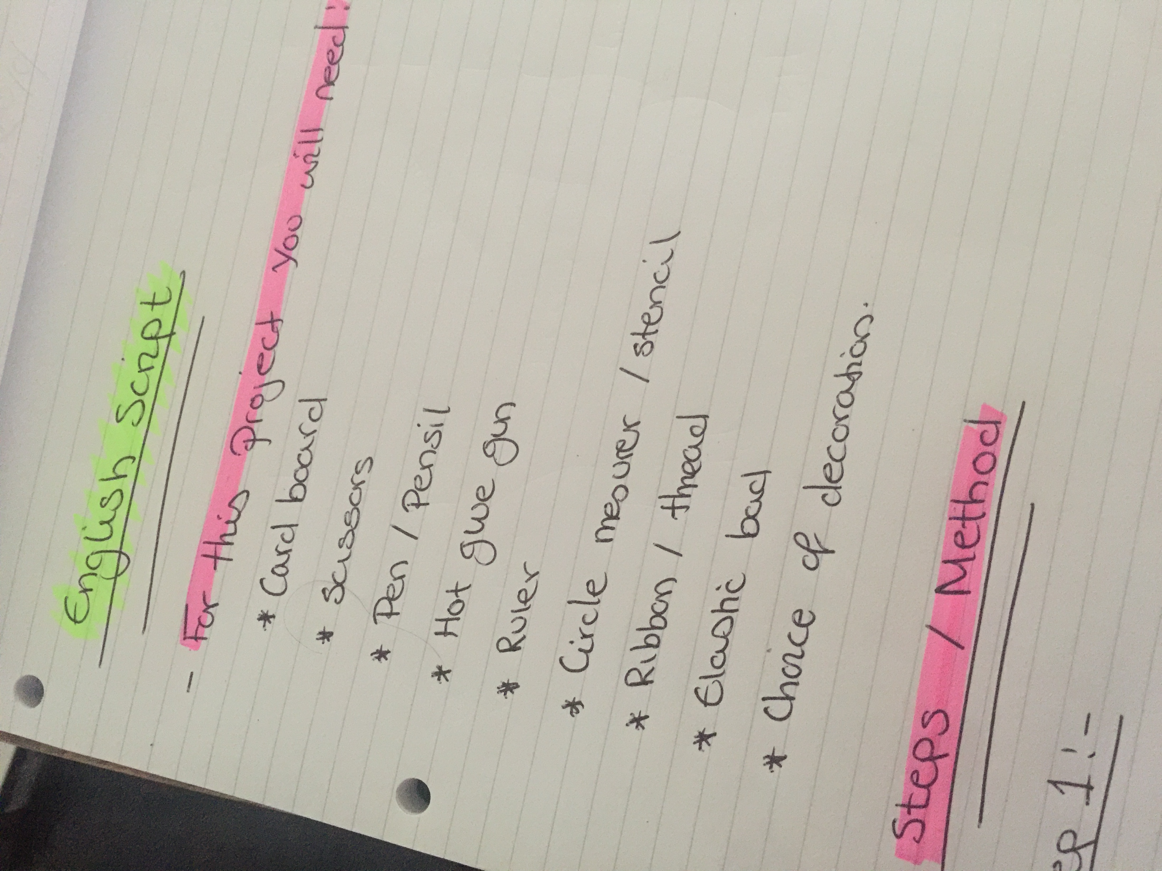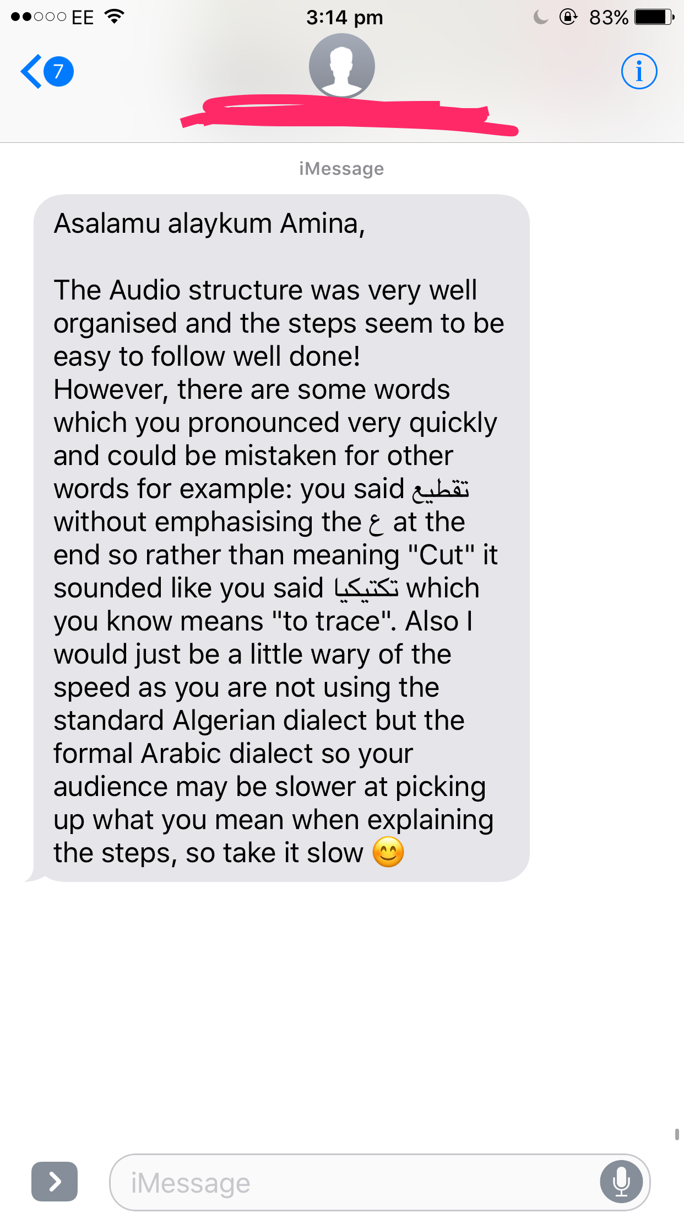  Link to Audio:  https://livecoventryac-my.sharepoint.com/personal/kenewaa3_uni_coventry_ac_uk/_layouts/15/guestaccess.aspx?guestaccesstoken=UX%2BVdUS62LaX4u%2F0HRwAzDH1sCgoc24yWzeQrYUZges%3D&docid=2_1079aa32fcb2d42f0ba6f20d45cd1c00c&rev=1&e=cOqx0c
What did you learn from this prototype?  (What were the results? What might you do differently next time as a result?) | I got a lot of verbal feedback from friends and family members however the main feed I was taking on board was from the head of the Arabic school who has a degree in the Arabic Language. She had given me pointers about the pronunciation of words as I speak fast, some words started to sound like other words with different meanings. The Arabic language is so complex as the change in tone when pronouncing a word can completely change it meaning. This is why I knew I had to create many prototypes of the script before perfecting it to high standards. I’m taking extra classes after work to master the formal way of speech.
How will you incorporate this learning into your project proposal? | The way I will incorporate this in to the project proposal is by deciding weather or not I will go through with recording audio as a step by step guide/ tutorial or if I would do it another way of just including subtitles or fancy text on screen. This prototype is allowing me to push my skills further and evaluate my progress when facing a lot of trials and errors and reproducing the content again.

